**Understanding the key drivers of profitability and optimize decision-making.**

**Key Predictive Features Identified:**

The model identified several key features that significantly impact airline profitability:

1. **Revenue per Available Seat Kilometer (ASK):**
   * **Impact:** Most influential positive predictor of profitability.
   * **Explanation:** Higher revenue generated per seat kilometer directly increases overall profit.
2. **Cost per ASK:**
   * **Impact:** Strong negative influence on profitability.
   * **Explanation:** Higher operational costs per seat kilometer reduce net profit margins.
3. **Maintenance Downtime (Hours):**
   * **Impact:** Significant negative effect on profit.
   * **Explanation:** Extended maintenance reduces aircraft availability, leading to fewer flights and revenue opportunities.
4. **Fuel Efficiency (ASK):**
   * **Impact:** Positive contributor to profitability.
   * **Explanation:** Improved fuel efficiency lowers fuel costs, enhancing profit margins.
5. **Delay (Minutes):**
   * **Impact:** Negative impact on profit.
   * **Explanation:** Flight delays increase operational costs and can reduce customer satisfaction.
6. **Maintenance Impact:**
   * **Impact:** Affects profitability by influencing operational efficiency.
   * **Explanation:** Effective maintenance strategies can optimize aircraft utilization.
7. **Delay Cost Impact:**
   * **Impact:** Additional negative effect due to costs associated with delays.
   * **Explanation:** Includes compensation, rescheduling, and cascading operational disruptions.
8. **Ancillary Revenue (USD):**
   * **Impact:** Positive, though to a lesser extent.
   * **Explanation:** Additional revenue streams like baggage fees and in-flight sales contribute to profits.
9. **Day of the Week Factors:**
   * **Impact:** Slight variations in profitability.
   * **Explanation:** Passenger demand fluctuates throughout the week, affecting load factors and revenues.
10. **Net Profit Margin (%):**
    * **Impact:** Reflects the overall profitability ratio.
    * **Explanation:** Indicates efficiency in converting revenue into actual profit.

**Model Interpretability with SHAP Values:**

To ensure the model's explainability, **SHAP (SHapley Additive exPlanations)** values were employed:

* **Purpose:** Quantify the contribution of each feature to the model's predictions.
* **Benefit:** Provides both global and local interpretability, allowing a clear understanding of how features influence profitability.

**Example:**

* Features like **Revenue per ASK** and **Fuel Efficiency** showed high positive SHAP values, indicating they greatly increase predicted profits.
* Conversely, **Cost per ASK** and **Delays** had negative SHAP values, highlighting areas where improvements can significantly boost profitability.

**Model Evaluation and Generalization:**

The model's performance and reliability were assessed using cross-validation:

* **Cross-Validation RMSE Scores:** [3518.97, 3498.53, 3483.43, 3526.76, 3492.57]
* **Mean CV RMSE:** **3504.05** with a standard deviation of ±16.29

**Interpretation:**

* **Low RMSE Values:** Indicates high predictive accuracy across all validation sets.
* **Low Standard Deviation:** Demonstrates the model's consistency and ability to generalize well to unseen data.

**Conclusion:**

The Gradient Boosting model successfully achieves the project objectives:

* **Prediction Accuracy:**
  + High accuracy in predicting airline profitability, enabling confident decision-making.
* **Interpretability:**
  + SHAP values provide actionable insights into the most impactful features.
  + Helps operators focus on areas like optimizing revenue streams and reducing operational costs.
* **Generalization to Unseen Data:**
  + Consistent cross-validation results confirm the model's robustness and applicability to real-world scenarios.

**Implications for Airline Operators:**

* **Strategic Decision-Making:**
  + Focus on enhancing revenue per ASK and fuel efficiency.
  + Implement cost-reduction strategies targeting operational and maintenance expenses.
* **Operational Efficiency:**
  + Minimize delays and maintenance downtime to improve profitability.
* **Revenue Optimization:**
  + Explore opportunities to increase ancillary revenue.

**Why we use RMSE??????**

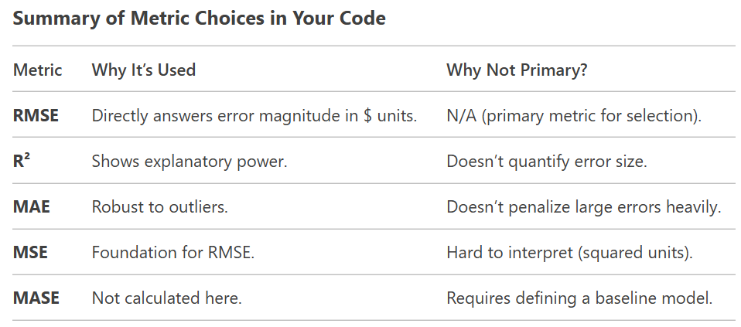

**Why RMSE Was Best for Our Project**

1. **Interpretability:** Stakeholders care about errors in dollars, not squared dollars.
2. **Error Sensitivity:** RMSE penalizes large errors (critical if big mistakes are costly).
3. **Standard Practice:** RMSE is the go-to metric for regression in most industries.

We could absolutely use other metrics (e.g., MAE for robustness), but **RMSE strikes the best balance** for our use case.